Chapter 9, Problem 53.

Find I₀ in the circuit in Fig. 9.60.

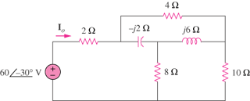

Figure 9.60
For Prob. 9.53.

